FACILITATION OF LEARNING IN AN OCCUPATIONAL CONTEXTS
SUMMATIVE MEMO

Module # | 242401001-KM-04
NQF Level | 5
Notional hours | 80
Credit(s) | 8
Development  Quality Partner | ETDP SETA
Occupation or Specialization | 242401001;Learning and Development Practitioner
Associated Occupation | 242401001;Learning and Development Practitioner

Name
Contact Address
Telephone (H)
Telephone (W)
Facsimile
Cellular
E-mail

Note to the learner
This Learner Guide provides a comprehensive overview of the module. It is designed to improve the skills and knowledge of learners, and thus enabling them to effectively and efficiently complete specific tasks.

Purpose
The main focus of the learning in this knowledge module is to build an understanding of the knowledge required to facilitate learning and development in a variety of occupational contexts to learners with different needs.

Topic elements to be covered include

- KM-04-KT01: Principles and models for facilitation planning and preparation (30%)
- KM-04-KT02: Facilitation principles, techniques and tools (50%)
- KM-04-KT03: Evaluating, reviewing and reporting on facilitation (20%)

Exemptions
No exemptions are currently recognized for any of the listed knowledge modules. An RPL approach is recommended for all listed knowledge modules.

Entry Requirements
NQF level 4 with Communication

Provider Accreditation Requirements for the Knowledge Module

Physical Requirements
- Learning and development resources aligned to the scope and content of the module
- Learner assessment resources (database, tools, records)

Human Resource Requirements:
- Access to facilitators of learning with subject matter expertise as evident from professional designations, or experiential competence or prior qualifications
- Access to assessment expertise in terms of subject matter related prior learning, experience and credibility
Legal Requirements
- Access to facilities that comply with occupational health and safety standards where contact learning or assessment sessions are delivered

Venue, Date and Time:
Consult your facilitator should there be any changes to the venue, date and/or time.
Refer to your timetable
Assessments

The only way to establish whether you are competent and have accomplished the learning outcomes is through continuous assessments. This assessment process involves interpreting evidence about your ability to perform certain tasks. You will be required to perform certain procedures and tasks during the training programmer and will be assessed on them to certify your competence.

This module includes assessments in the form of self-evaluations/activities and exercises. The exercises, activities and self-assessments will be done in pairs, groups or on your own. These exercises/activities or self-assessments (Learner workbook) must be handed to the facilitator. It will be added to your portfolio of evidence, which will be proof signed by your facilitator that you have successfully performed these tasks.

Listen carefully to the instructions of the facilitator and do the given activities in the time given to you.

  Books | This icon means that other books are available for further information on a particular topic/subject.
  References | This icon refers to any examples, handouts, checklists, etc…
  Important | This icon represents important information related to a specific topic or section of the guide.
  Activities | This icon helps you to be prepared for the learning to follow or assist you to demonstrate understanding of module content. Shows transference of knowledge and skill.
  Exercises | This icon represents any exercise to be completed on a specific topic at home by you or in a group.
  Tasks/Projects | An important aspect of the assessment process is proof of competence. This can be achieved by observation or a portfolio of evidence should be submitted in this regard.
  Workplace Activities | An important aspect of learning is through workplace experience. Activities with this icon can only be completed once a learner is in the workplace
  Tips | This icon indicates practical tips you can adopt in the future.
  Notes | This icon represents important notes you must remember as part of the learning process.

KM-04-KT01: Principles and models for facilitation planning and preparation

KT0101 | Occupational curriculum, qualification and learning program outcome analysis
KT0102 | Target group analysis
KT0103 | Facilitation plans (scheduling, logical sequencing and flow of concepts, lesson plans, group and individual activities)
KT0104 | Learning environment (including resources, cost effectiveness, impact on environment, use of blended learning and other methods)

ACTIVITY
1

Outline the Principles and models for facilitation planning and preparation
Facilitation Principles
Brainstorming
Many times, a team will need to discuss a topic in an effort to come up with solutions to a problem. In these instances, a facilitator can utilize the brainstorming tool which is designed to generate many ideas in a short period of time. This tool is only as good as the facilitator who’s using it because this tool requires that the facilitator create a positive, non-judgmental atmosphere. When used properly, this tool will allow for team members to be uninhibited and creative in their thinking. During the brainstorming session, the facilitator should encourage team members to randomly shout out ideas or potential solutions that come to mind. All ideas should be recorded for future discussion. At this point, none of the ideas are discussed or judged. Any judgment at this stage would stifle the creativity in the room. The facilitator should remember to encourage participation from all members to ensure that multiple perspectives are contributing to the final solution. For teams that are dominated by one or two group members, a facilitator can use a more structured approach where members are directed to speak in turns, going around the room in order.

If the topic at hand is particularly sensitive, a facilitator can make the process anonymous by asking team members to write down their ideas on paper and then have the ideas summarize by the facilitator or trusted group member.
Force Field Analysis
This is another technique that a facilitator can use in order to identify problems and generate potential solutions. Oftentimes, in order to accomplish a goal, it is important for the team to understand the current forces that are acting in favor of the goal and against the goal. These two forces, called the Driving Forces and Restraining Forces both work to influence the goal, in opposite directions.
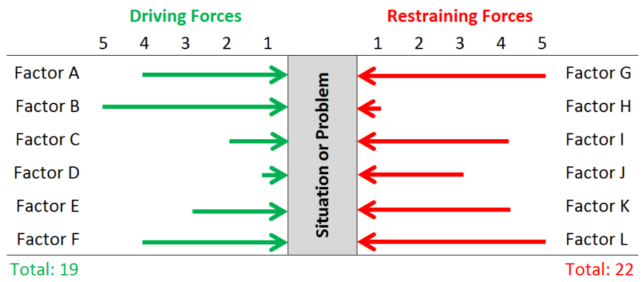
Nominal Group Technique (NGT)
Once a group has a list of potential solutions to a problem, it is often then necessary for the facilitator to assist the group in choosing the best solution. Let’s say that you’ve been able to narrow your list of potential solutions down to the final 6 best ideas. You’ve also got 5 team members, and you can’t reach agreement as to which particular solution should be executed. A facilitator can use the Nominal Group Technique to gain team agreement.
Conflict Resolution
As you likely already know, conflict is unavoidable. Conflict will often occur as a team attempts to implement a quality initiative which normally requires much change.
Change can drive conflict. Conflict can also occur when mutually exclusive views or opinions are being discussed. Below is a handful of work situations or causes where conflict can arise due to the existence of mutually exclusive opinions:
- Organizational Structure causing competing goals & priorities
- Actual or perceptual differences in values, ideals or objectives
- Personality clashes between team member or groups
Conflict is always amplified by emotions like fear, distrust, anger, frustration, or personal bias. This is why a facilitator must focus on making objective, data driven decisions. This will remove as much emotion from the decision as possible.

KM-04-KT02: Facilitation principles, techniques and tools

KT0201 | Adult learning and facilitation principles, models and theories
KT0202 | Facilitation tools and techniques (such as encouraging communication, questioning, verbal and non-verbal communications, professional and ethical conduct, technology usage, flip charts, managing conflict and diversity)
KT0203 | Key facilitation concepts (group dynamics, classroom management, inclusive education)
KT0204 | Learning application and internalization concepts (such as experiential learning, presentations, role play, case studies, group work, guided investigations, field work, experiments, project-based assignments, distance, RPL and research, scenario-based activities, observation)
KT0205 | Best practice facilitation concepts and practices

ACTIVITY
2

Adult learning and facilitation principles, models and theories
Adult Learning
Adult learners have a different approach to learning. By the time you reach adulthood, you’re most likely responsible for your own success and you’re perfectly capable of making your own decisions once you have the information you need. Adults learn best when learning is focused on adult students, not on the teacher. This is called andragogy, the process of helping adults learn.
Principles
The principles of andragogy flow directly from an understanding of the characteristics of adults as learners and can be recognized when we understand the characteristics of adults and see the way those characteristics influence how adults learn best. Teachers who follow the principles of andragogy when choosing materials for training and when designing program delivery, find that their learners progress more quickly, and are more successful in reaching their goals. The Canadian Literacy and Learning Network outlines the 7 key principles of adult learning. In other words, these 7 principles distinguish adult learners from children and youth.
- Adults cannot be made to learn. They will only learn when they are internally motivated to do so.
- Adults will only learn what they feel they need to learn. In other words, they are practical.
- Adults learn by doing. Active participation is especially important to adult learners in comparison to children.
- Adult learning is problem-based and these problems must be realistic. Adult learners like finding solutions to problems.
- Adult learning is affected by the experience each adult brings.
- Adults learn best informally. Adults learn what they feel they need to know whereas children learn from a curriculum.
- Children want guidance. Adults want information that will help them improve their situation or that of their children

KM-04-KT03: Evaluating, reviewing and reporting on facilitation

KT0301 | Review models and processes (learner response, peer review, self-evaluation, client feedback, assessment results)
KT0302 | Best reviewing, reporting and feedback practices for continual improvement

ACTIVITY
3

Outline the steps of a review
Steps of a Review
- Regardless of the type of model review, the basic steps are the same. The steps of a formal review (informal reviews will be discussed later) are:
- The team prepares for review. The artifacts to be reviewed are gathered, organized appropriately, and packaged so they can be presented to the reviewers.
- The team indicates it is ready for review. The project team must inform the review facilitator (often a member of your quality assurance department, if you have one) or another project manager when it is ready to have its work reviewed as well as what the team intends to have reviewed.
- The review facilitator performs a cursory review. The first thing the review facilitator must do is determine if the project team has produced work that is ready to be reviewed. The manager will probably discuss the team's work with the team leader and do a quick rundown of what it has produced. The main goal is to ensure the work to be reviewed is good enough to warrant getting a review team together.

